

**Data Science Project**

**Deliverable-II**

**Section: CS-A**

**Group Members:**

Monisa Hassan Alvi (17L-4098)

Muhammad Abdullah Farooqi (17L-4122)

Rimsha Shakeel (17L-4134)

Aiza Nadeem (17L-4338)

**Part 1: How many classes you have considered to tackle this problem and how?**

**Solution:**

We have considered two classes. Pakistani CNIC and UK Passport. Each class is having 5 labels in them i-e Country, Name, Identity Card Number/Passport Number, Date of Birth and Date of Expiry.

**Part 2:** **No of Images.**

**(i) How many original images e.g., for Pakistan and UK Id cards.**

**Solution:**

We took 25 images for Pakistan CNIC and 25 images for UK Passport.

**(ii) How many you have in total after annotations.**

**Solution:**

We annotated all 25 images for both classes. After augmentation we got 4550 images i-e 2275 images for each dataset.

**(iii) How many images for training and how many for test?**

**Solution:**

We are taking 80%images as training images and 20% images as test images. More specifically, 1820 images are used for training of data and 455 images are used as test images for each dataset.

**Part 3: What augmentation method/approach you used?**

**Solution:**

In our project, the augmentation method which we have used is rotation. We have rotated the images at every 4 degrees. In this way, from one image 90 modified versions have been created using rotation.

**Part 4: Provide annotation files for all images (original+annotated).** **Also provide one example original image of e.g., UK and PK and its annotation and similarly, one augmented image of both countries with annotation file.**

**Solution:**

All these annotation files are present in the folder submitted with project files. The augmented images size became very large when placed in folder or copied in document. You can find one example of each class below.

One example of each class with its augmented file and annotation is given below:

**Pakistan CNIC:**

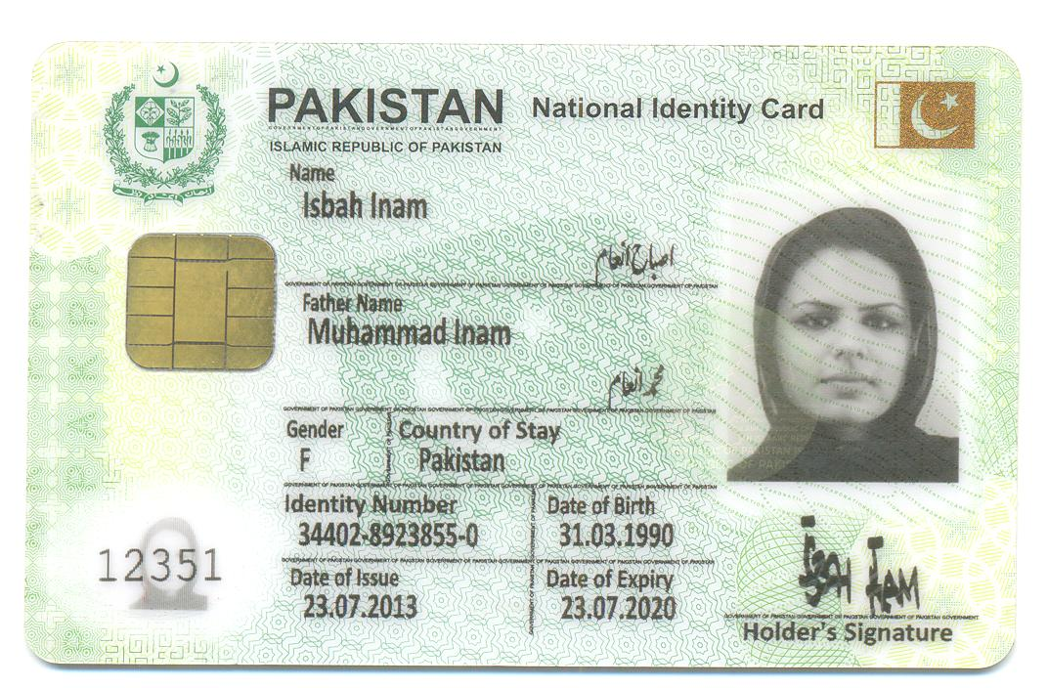

**Original Image Annotations:**

Width: 1072

Height: 704

Depth: 3

Country: (269,84),(524,131)

Name: (303,191),(447,228)

ID Card Num: (298,529),(500,566)

Date of Birth: (566,531),(700,567)

Date of Expiry: (571,605),(703,642)

**Augmented Image Pakistan CNIC:**

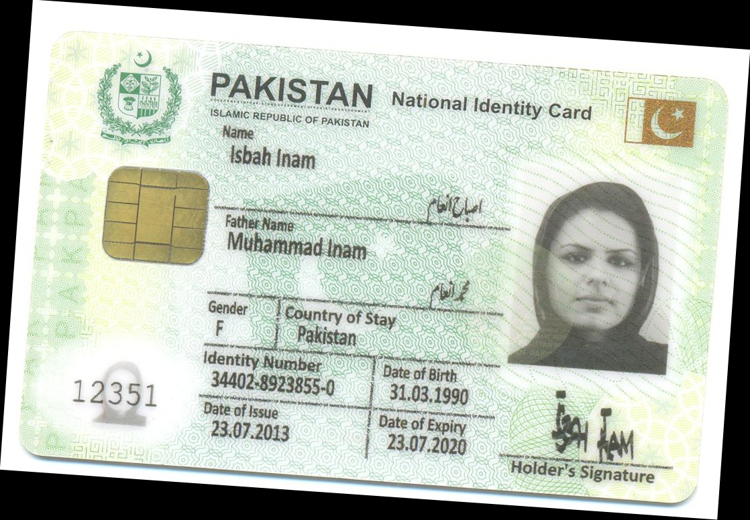

**Augmented Image Annotations:**

Width: 1118

Height: 777

Depth: 3

Country: (305,99),(561,169)

Name: (339,213),(477,258)

ID Card Num: (309,547),(505,593)

Date of Birth: (577,567),(703,611)

Date of Expiry: (573,641),(701,683)

**Uk Passport:**

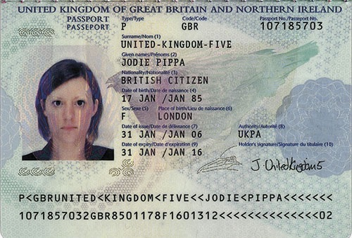

**Original Image Annotations:**

Width: 500

Height: 338

Depth: 3

Country: (22,6),(157,21)

Name: (171,80),(266,97)

Passport Number: (365,29),(464,44)

Date of Birth: (170,132),(290,146)

Date of Expiry: (170,209),(289,226)

**Augmented Image Uk Passport:**

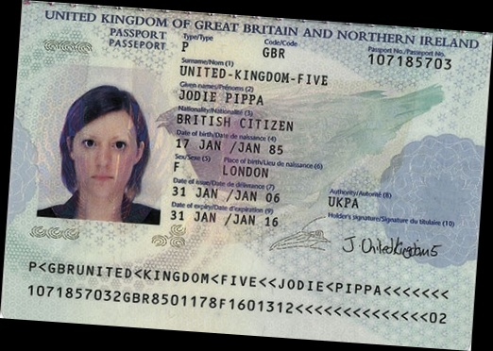

**Augmented Image Annotations:**

Width: 522

Height: 372

Depth: 3

Country: (42,6),(180,29)

Name: (187,92),(282,113)

Passport Number: (387,53),(480,75)

Date of Birth: (182,143),(302,165)

Date of Expiry: (177,220),(297,242)

**Part 5: Provide all code files (main code +augmentation code).**

**Solution:**

Provided in the folder.

**Part 6: Also mention the piece of code for transfer learning.**

**Solution:**

**Code for transfer learning:**

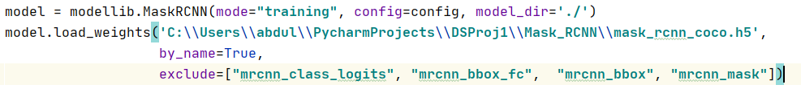

model.load_weights(**'C:**\\**Users**\\**abdul**\\**PycharmProjects**\\**DSProj1**\\**Mask_RCNN**\\**mask_rcnn_coco.h5'**,

by_name=True,

exclude=[**"mrcnn_class_logits"**, **"mrcnn_bbox_fc"**, **"mrcnn_bbox"**, **"mrcnn_mask"**])

**Which and how many layers you have removed and on how much data you retrained?**

**Solution:**

The 4 layers specified in exclude are being removed and they have been retrained. This includes the output layers for the classification label, bounding boxes, and masks. The data that has been retrained are 3640 images.

**Part 7: Provide detail on all the experiments.**

Firstly, the data was annotated and then it was augmented to create more images. After this the coco pre-trained model was used in transfer learning. The transfer learning code and details of layers are provided above. After this the model was retrained for both classes for output layers and test images were given that were provided as an output by model.

**Part 8:** **Report accuracy (How many cards were test. How many labels correctly identified and how many were missed for each class type?)**

**Solution:**

We got very good accuracy. We tested 5 cards by ourselves from each dataset and all labels were identified from both cards correctly. No label was missed by the trained model. The confidence threshold was 0.9 for Pakistani CNIC and 0.8 for Uk Passport. The examples of labelled images from both classes are given below.

